**Training Dataset:**

**Step 1 :**

The dataset consists of patient information such as :

* Age : integer
* Height : integer
* Weight : float
* Gender : Code 1 or 2
* Systolic blood pressure : integer
* Diastolic blood pressure : integer
* Cholesterol : 1,2 of 3(normal, above normal and well above normal)
* Glucose : 1,2 of 3(normal, above normal and well above normal)
* Smoking : binary
* Alcohol intake : binary
* Physical activity : binary
* Cardiovascular disease : binary (presence)

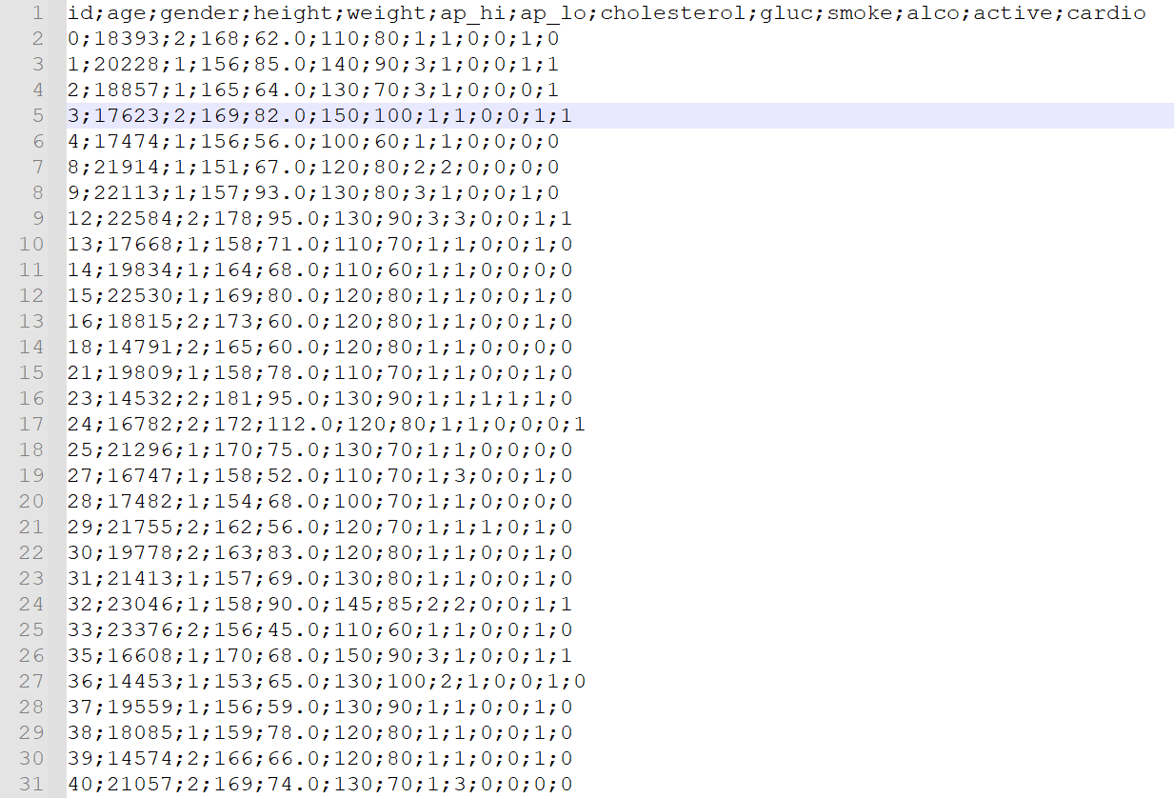

**Jadbio :**

**Step 2 :**

Create new project

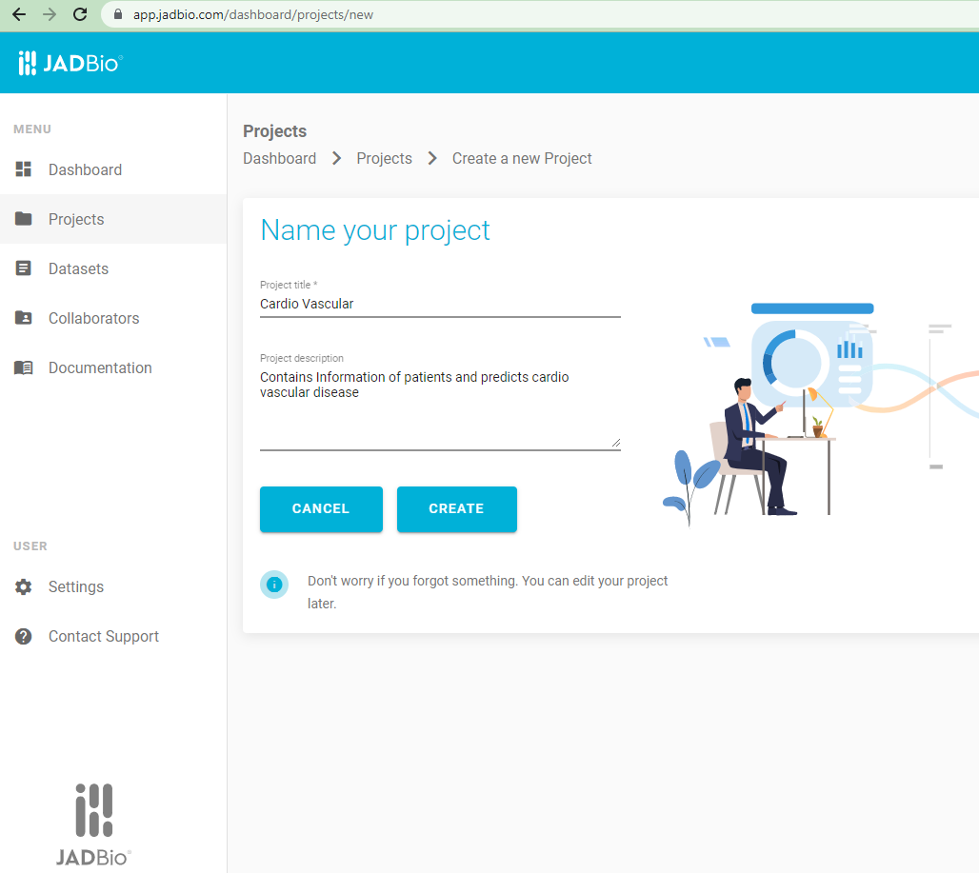

**Step 3:**

* Add training data set
* Specify file layout - if file contains the feature names, and if file has sample names

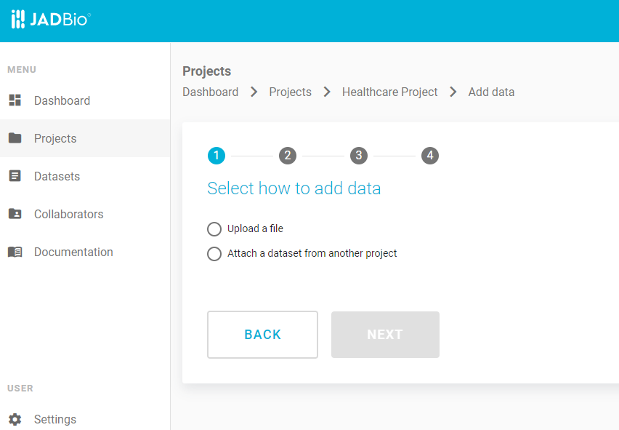

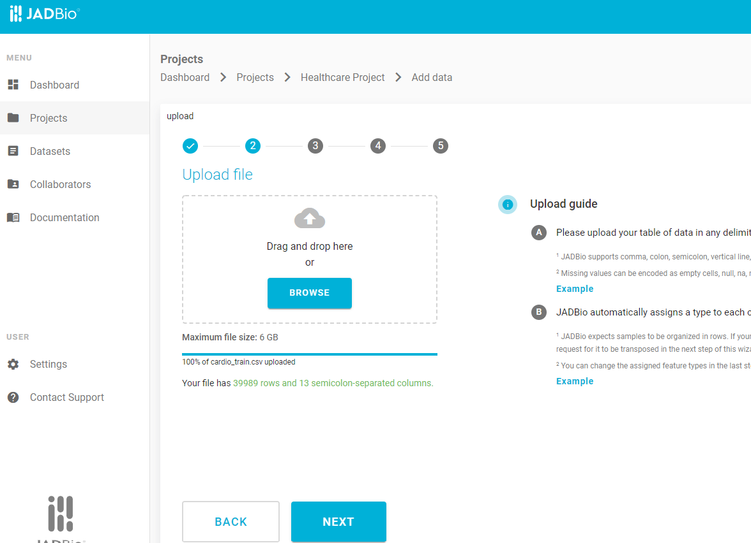

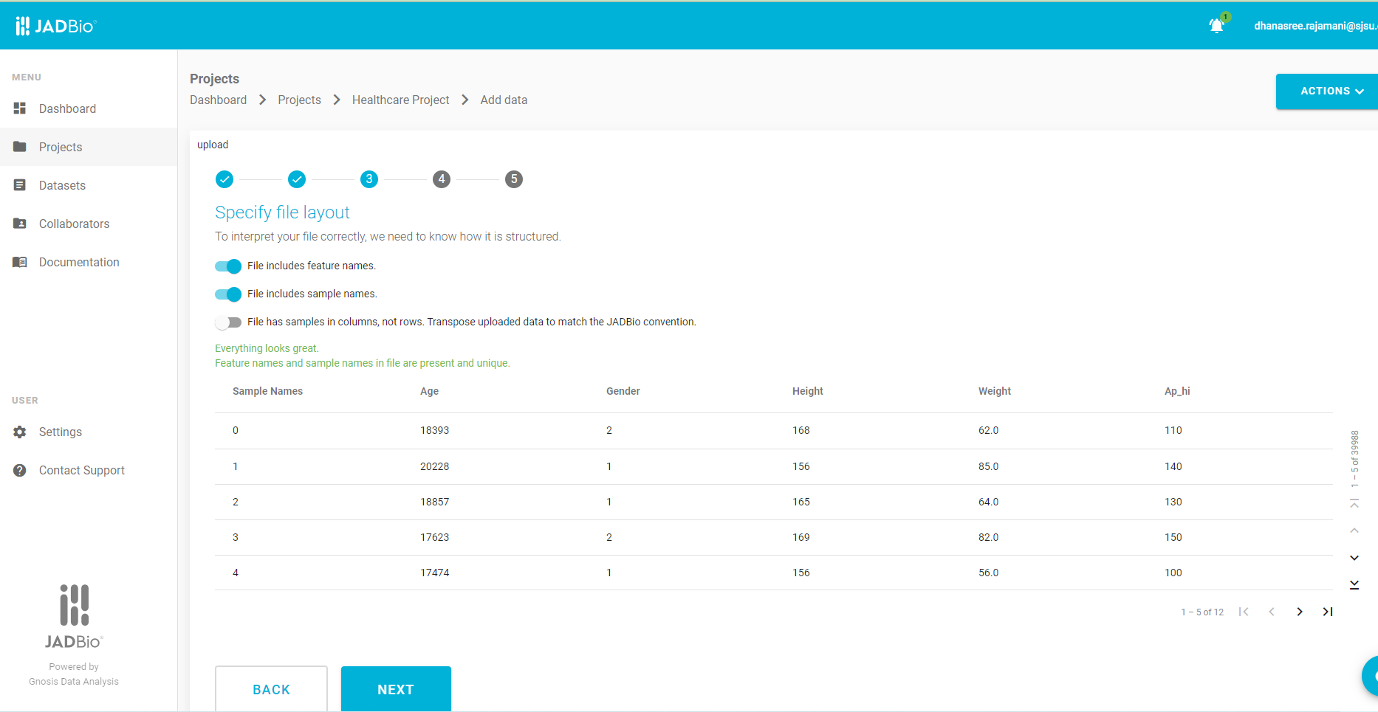

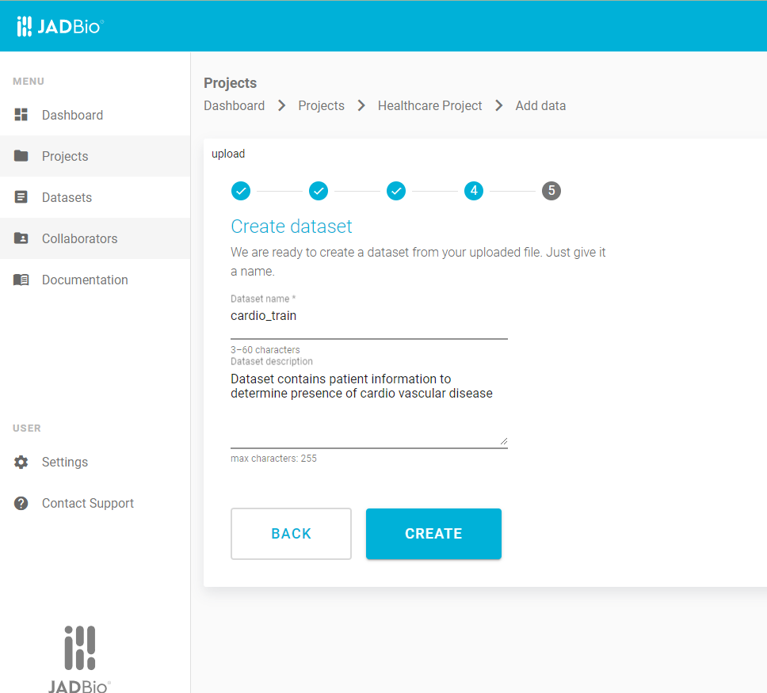

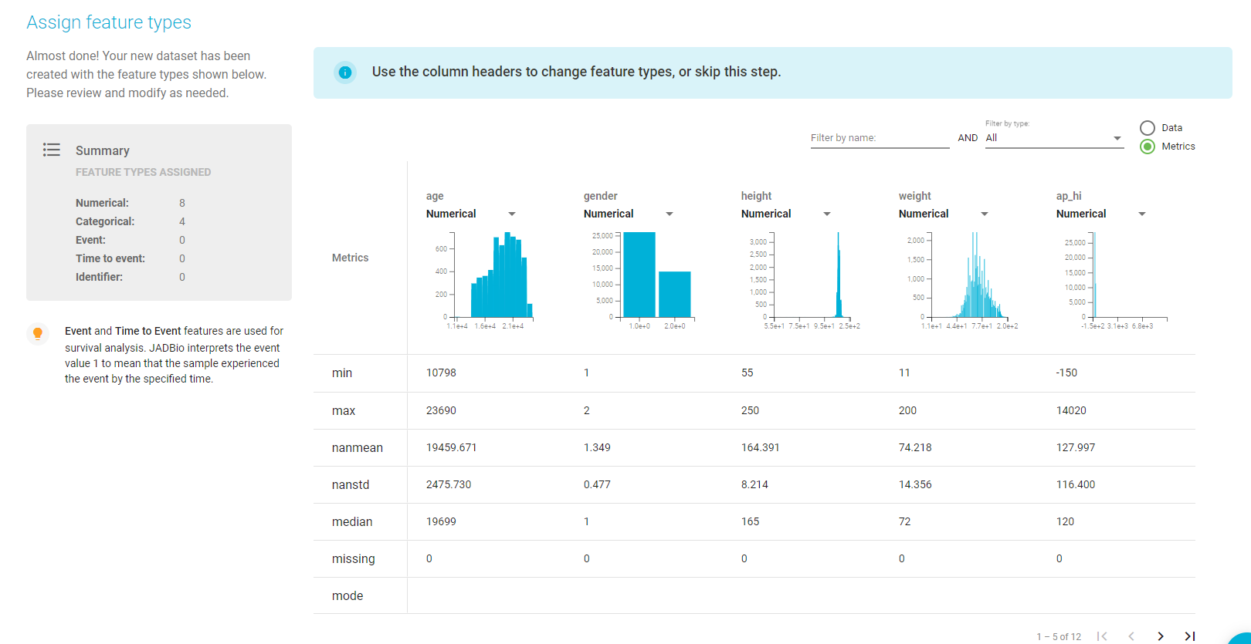

**Step 4:**

* Perform Analysis, choose the outcome which has to be predicted
* I have chosen Cardio to predict presence of absence of cardiovascular disease

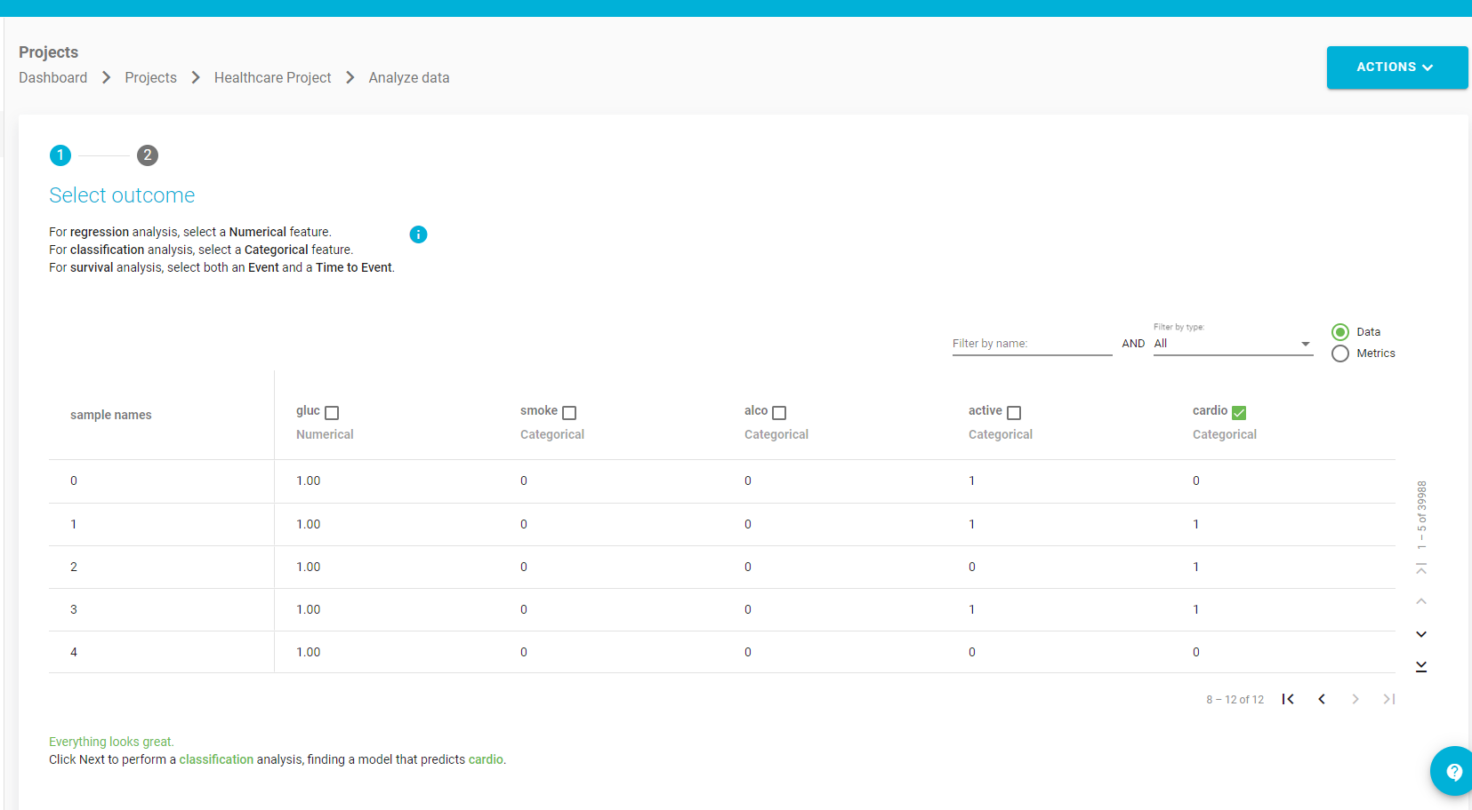

Perform analysis - choose option to include only the relevant features

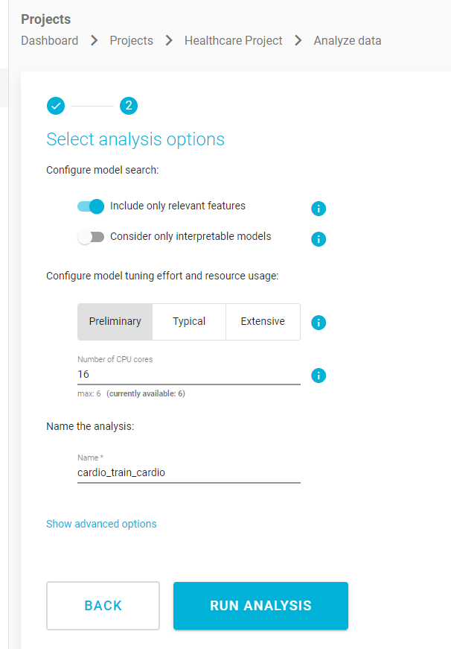

Analysis progress:

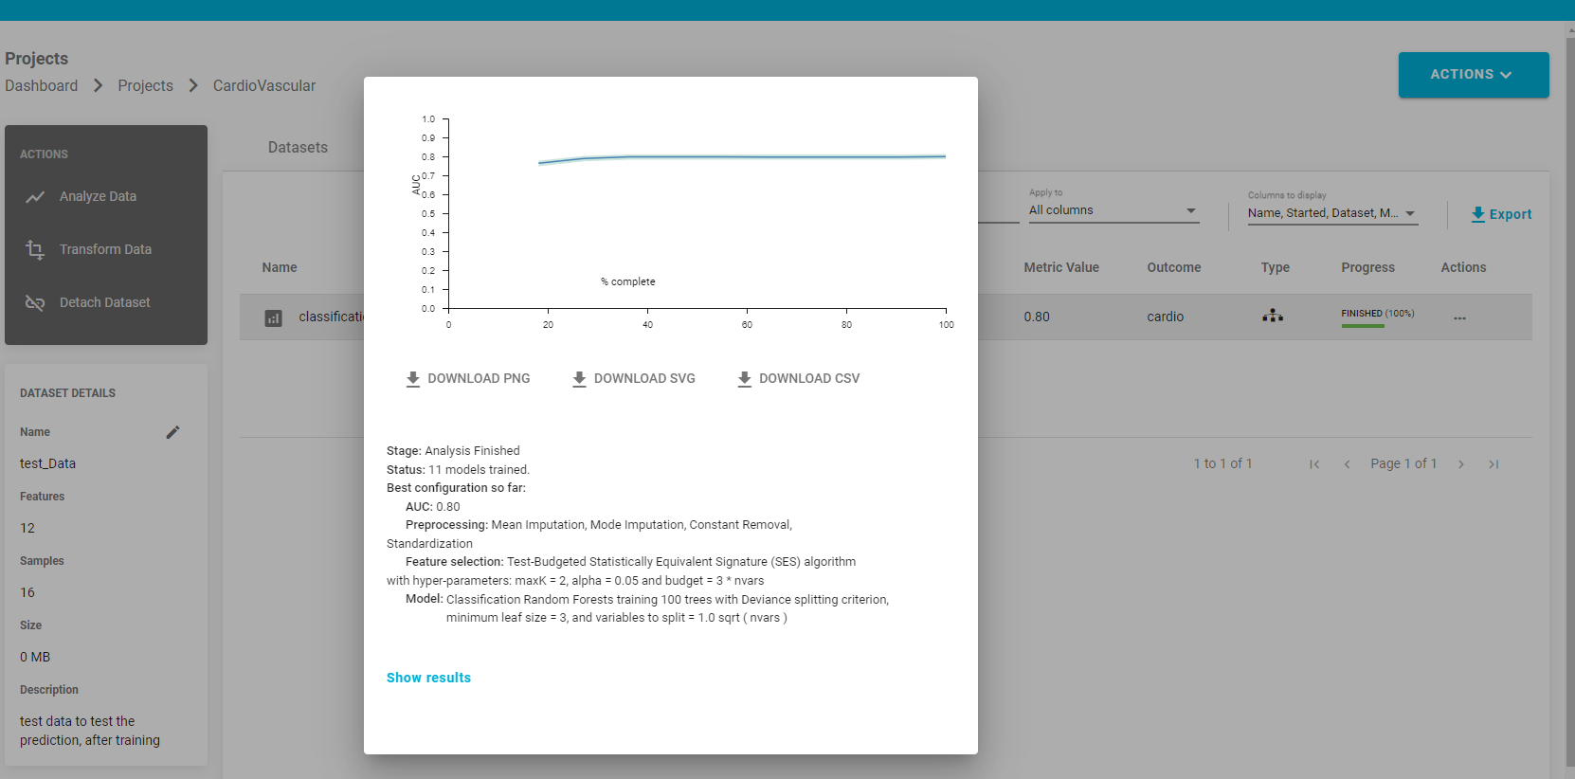

Feature selection:

* Denotes the features that have been selected to predict the outcome

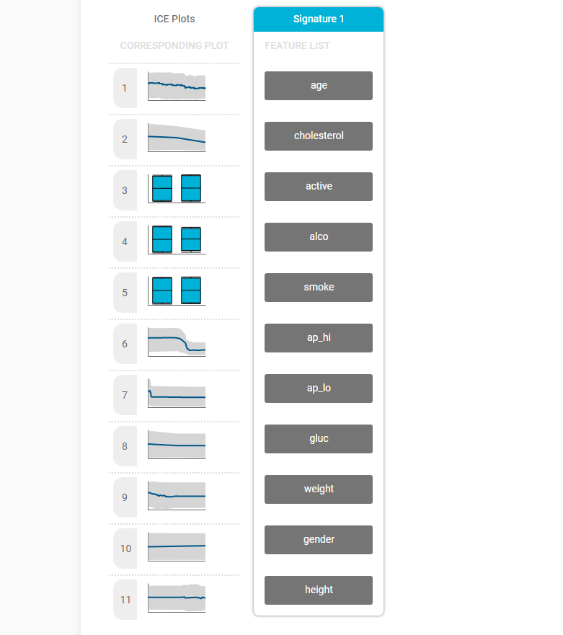

Feature Importance:

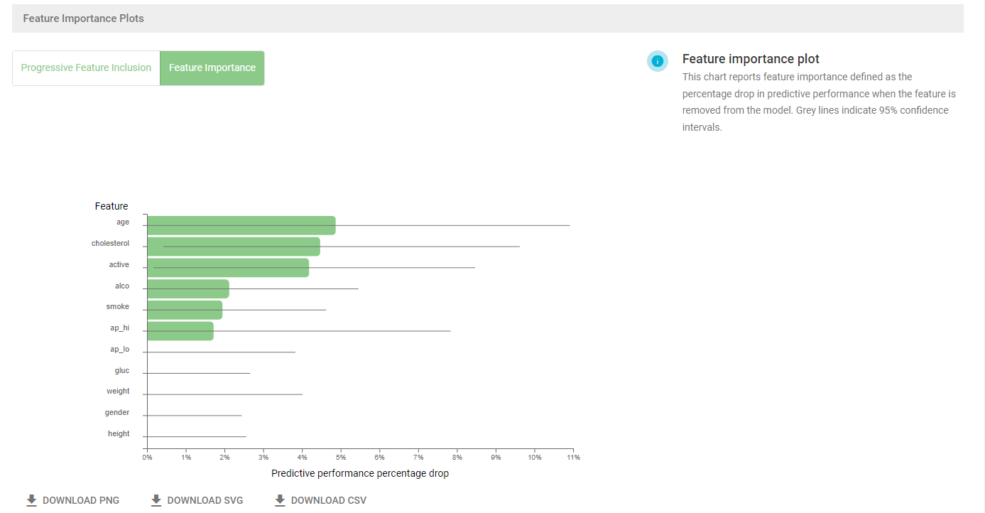

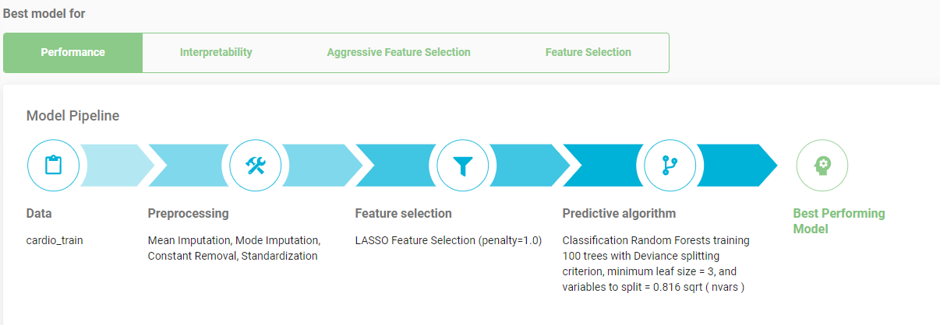

Accuracy of prediction:

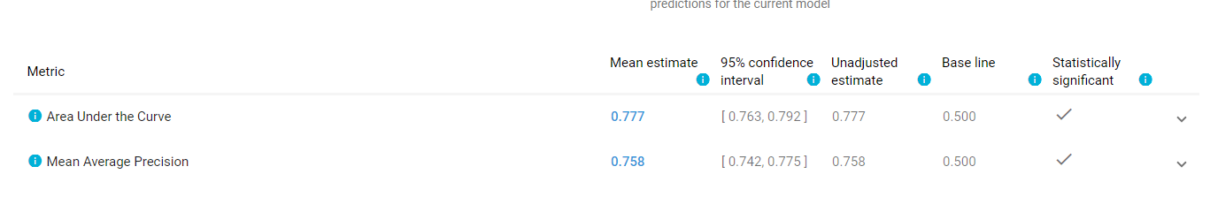

**Step 5:**

Apply model

* Once the model is trained, we have given a test patient dataset for the model to predict outcome - presence or absence of cardiovascular disease

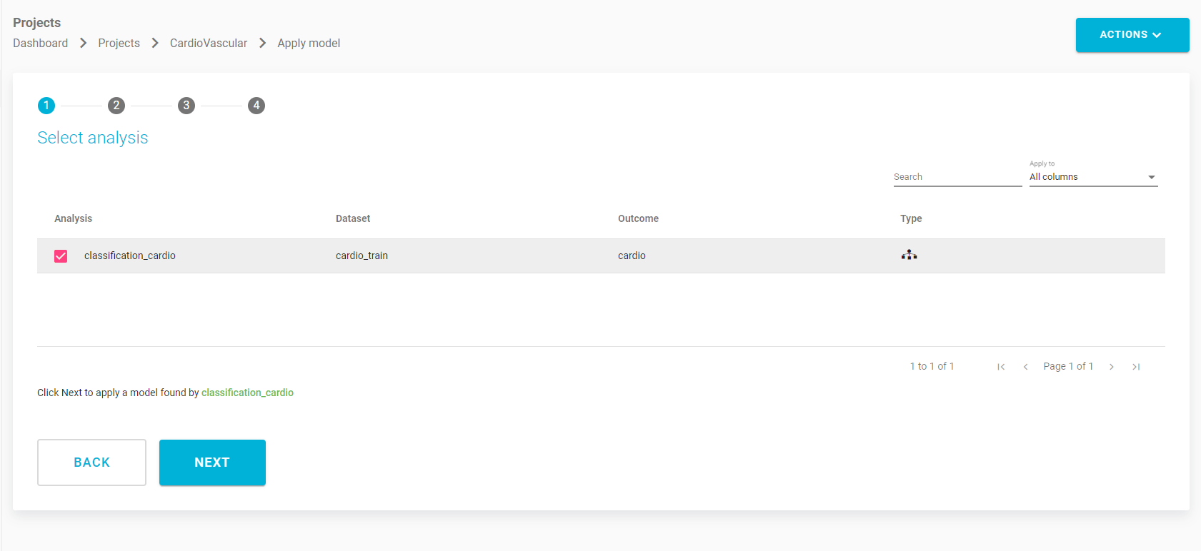

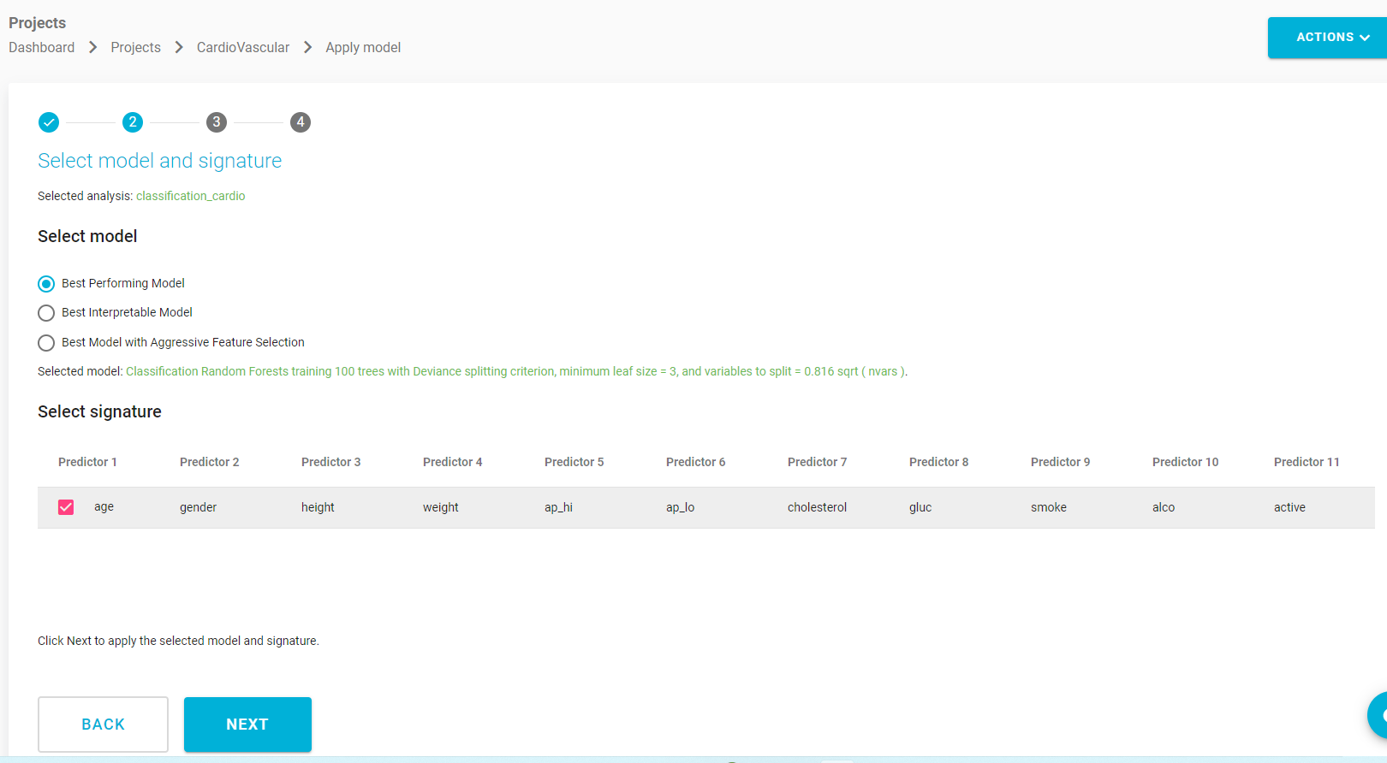

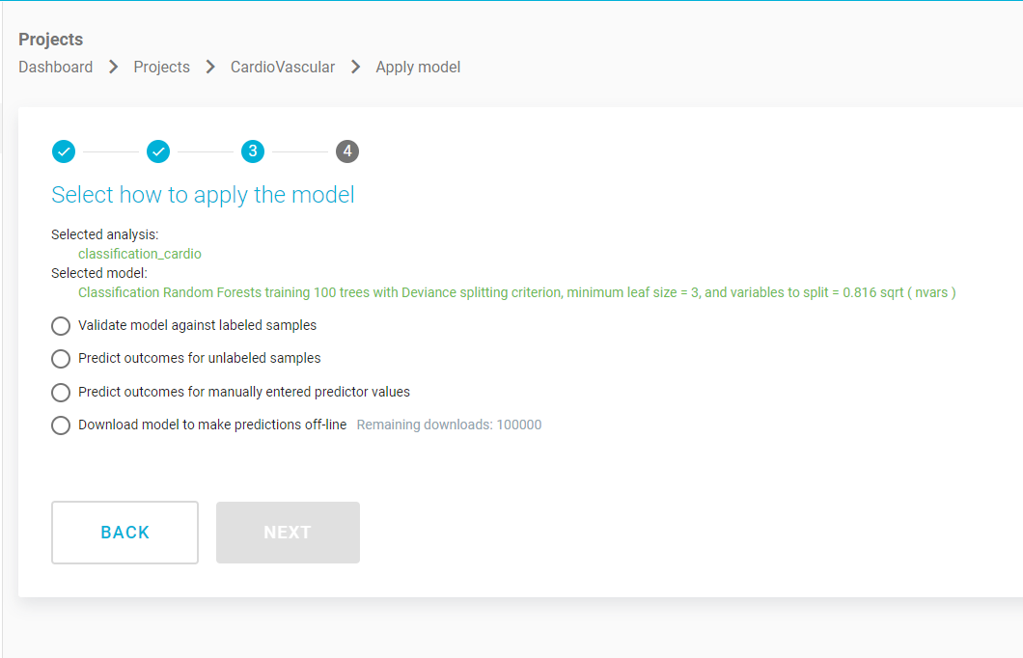

We use validate model against labeled samples

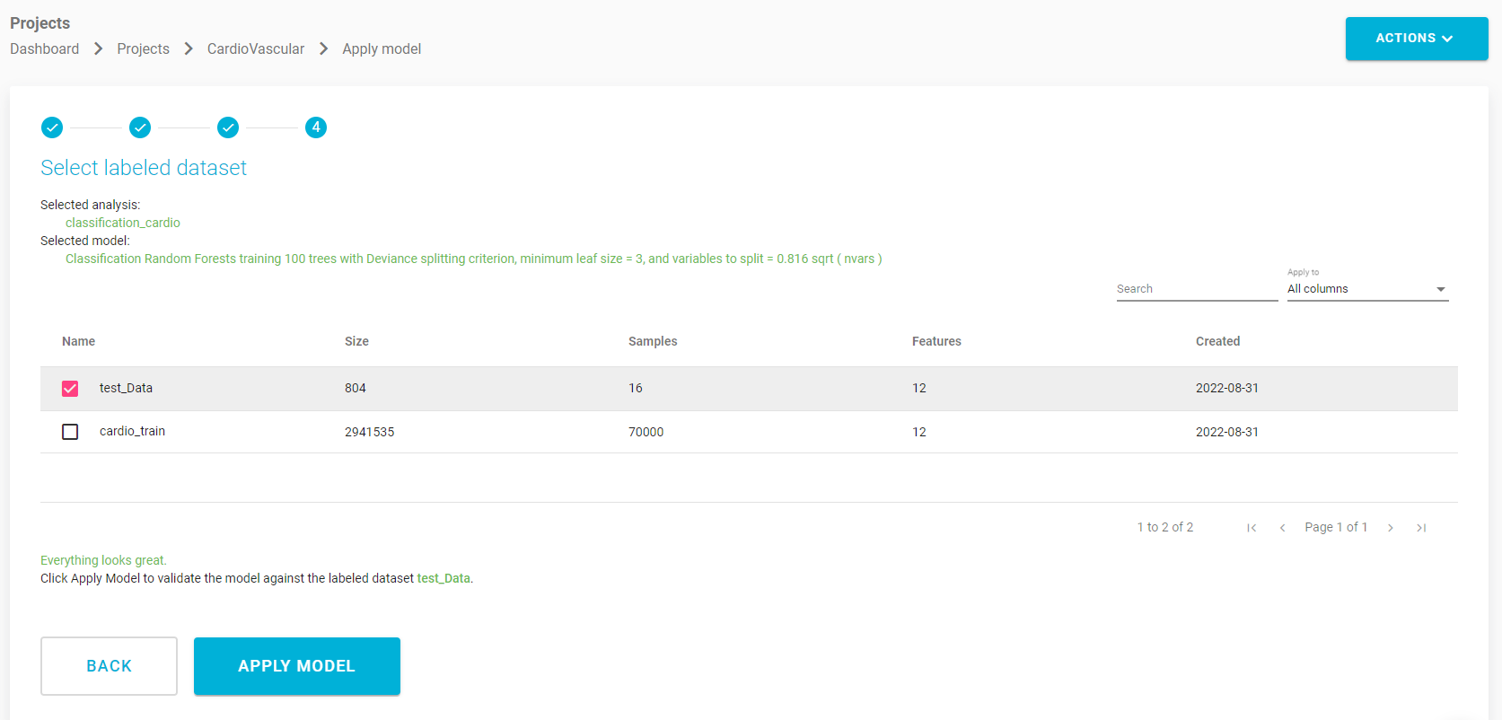

Applied Models :

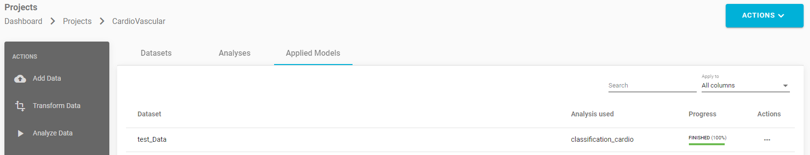

**Step 6 :**

* Confusion Matrix : Indicates True Positive, False Positive, True Negative and False Negative
* Indicates accuracy of the classifier.

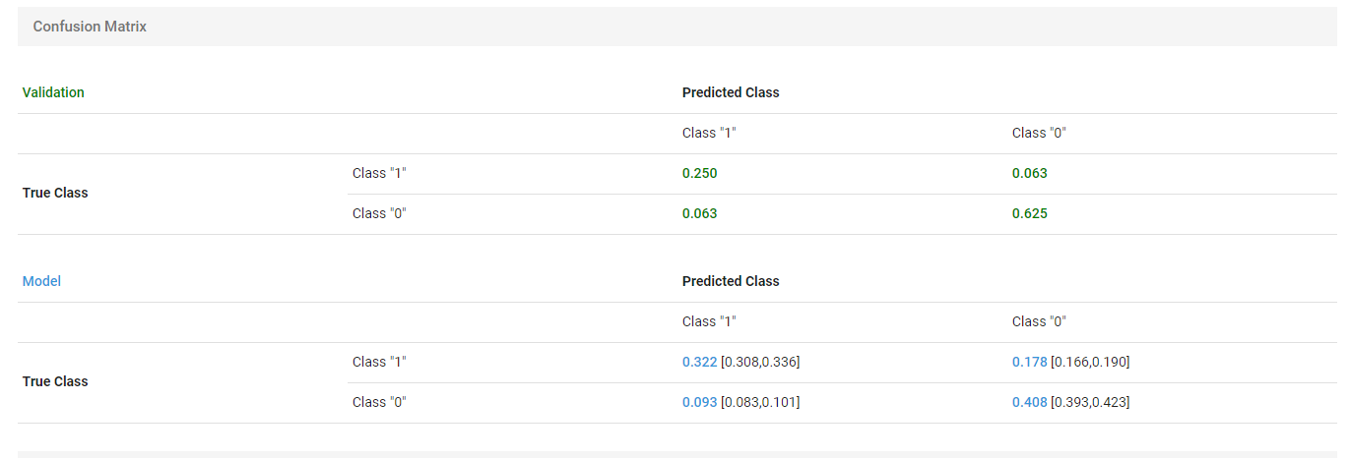

**Step 7:**

* View Predictions

